|  |
| --- |
| ENTER THE VOID |
| VOID SAVIOUR |
| **[2D-SPACESHOOTER]** |
| Version 1  All work Copyright © 2015 Centennial College.  All rights reserved. |
| **[Abobaker Belal - 300748727]** |
|  |



**Insert a Company Logo here**

|  |
| --- |
| October 5th 2015 |

Table of Contents

Contents

Version History 3

Game Description 4

Controls 4

Interface Sketch 5

Menu and Screen Descriptions 6

Characters/Vehicles 9

Enemies 9

Scoring 9

Sound Index 10

Art / Multimedia Index 10

Sources 12

Version History

**September 20: Version 1**

Simple setup of the game, found sprites and audio to use, and created all folders, and game objects.

**September 25: Version 2**

Touch up on the game objects and added components (scripts)

**September 29: Version 3**

Added player control, and background loop.

**October 2: Version 4**

Touch up on the scripts (colliders, audio, etc.)

**October 3: Version 5**

Added scoring and death visuals to the screen

**October 5: Version 6**

Created Menu scene, end game scene.

Game Description

**STORY:**

VOID SAVIOUR is a 2D platform game, where the player is playing the role of a hero. The game takes place in an unknown planet where humans were looking to possibly inhabit. Due to some issues with the spacecraft carrying the humans, they had to land on one of the small moons of the planet. The spacecraft caused an unbalance in the gravitational force of the moon causing it to collapse within itself. Initial reports stated all the passengers were presumed to be dead. Then one day headquarters received a signal for help from one of crafts. Headquarters general (Sion), decided to send one brave soldier (Jax) to scout the area of any survivors.

The player will be playing the role of Jax in the game, they are in charge of the spacecraft. His main goal is to save as many survivors as he can, while still tracking the craft that sent the signal. But because the moon collapsed there are now a lot of asteroids making the mission very dangerous.

**Description:**

The game starts off with the main menu giving the option to start the game. Once the start button is selected, the main game scene is launched, where Jax will have to save as many survivors as he can. Once the player has no more lives left or they have beat the level, another scene will come up where it will show their score.

Controls

The main controls for this game are mouse and keyboard.

KEYBOARD CONTROLS:

W OR up-arrow =Forward  
A OR left-arrow =Move-Left  
S OR down-arrow =Move-Down  
D OR right-arrow =Right-Arrow

Mouse Controls:

Left-Click = Shoot laser

Interface Sketch

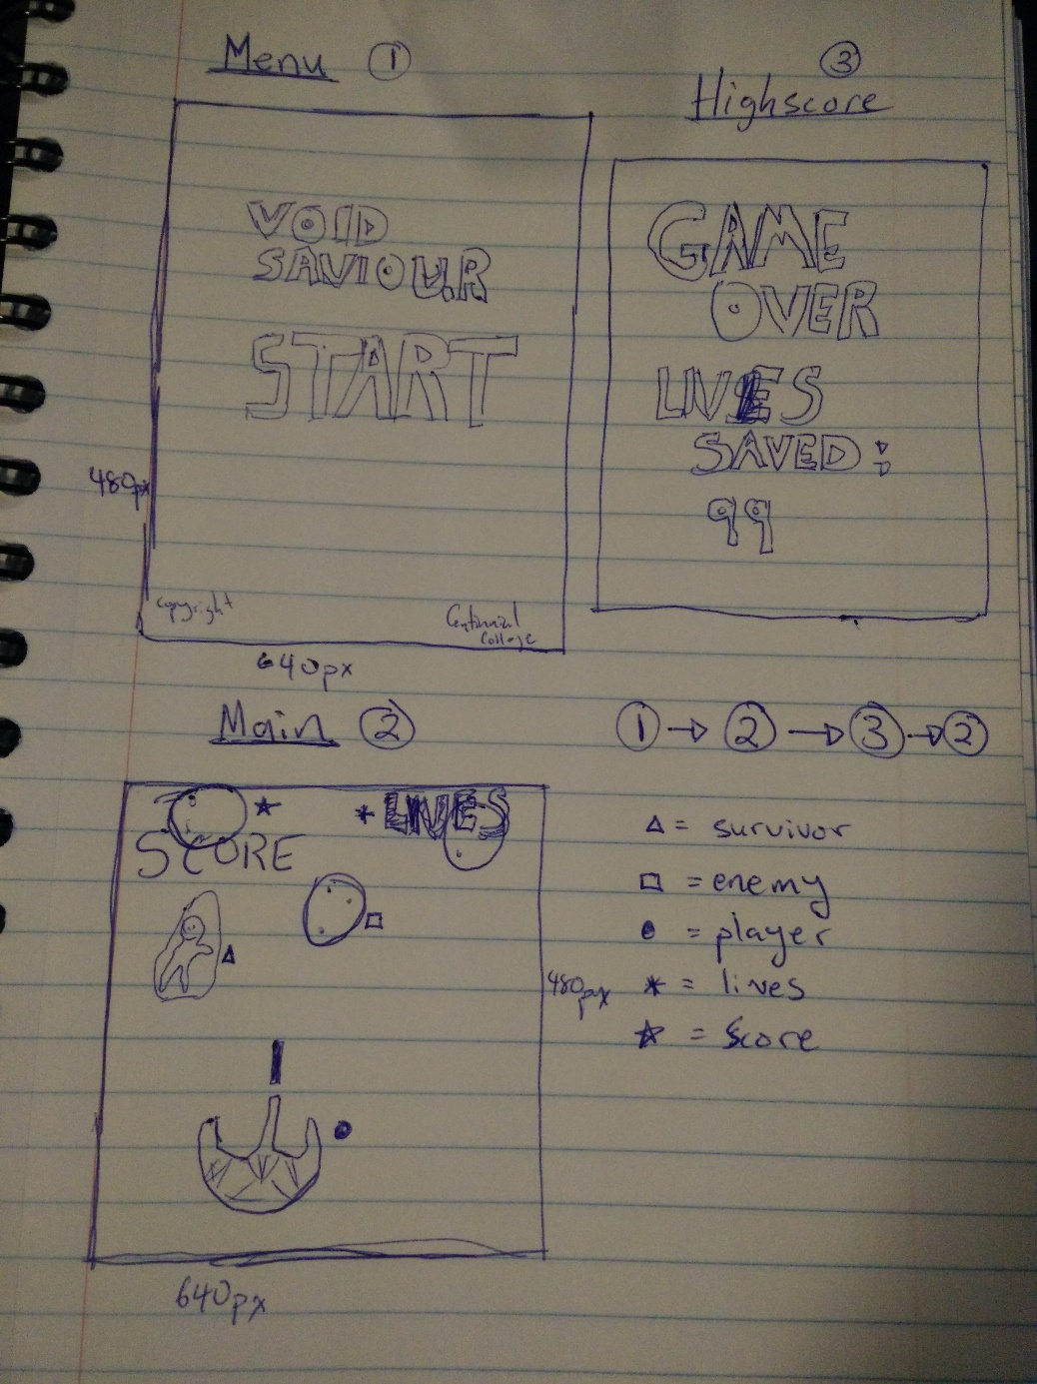

Menu and Screen Descriptions

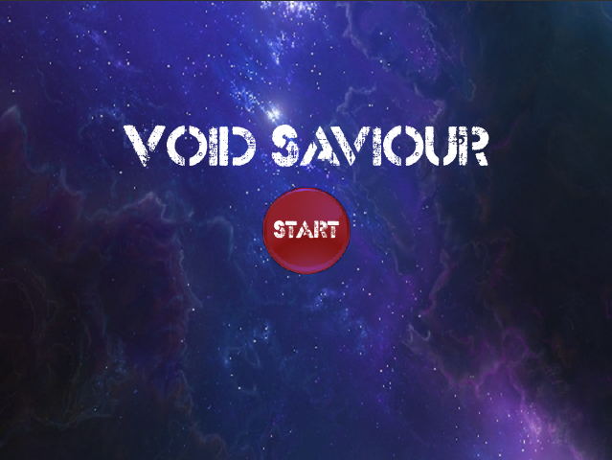

Game Name

Start Button

The Main menu of the screen is a very simple to use interface with just one button. This button allows the user to start the game.

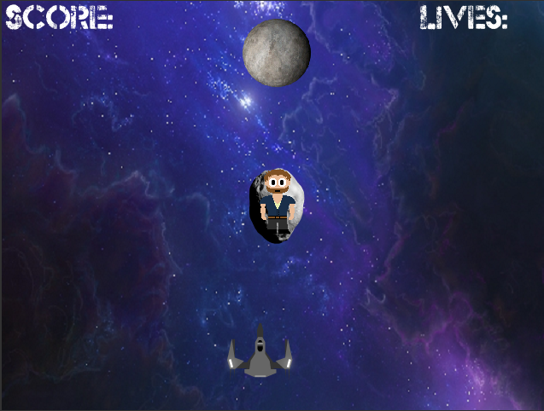

Asteroid

Survival

Jax

Lives

Score

This will be the in-game interface, the player will be controlling Jax’s spacecraft located down at the bottom of the screen. Score will be displayed at top left, and lives will be displayed at top right. Main goal of the game is to save as many survivors as you can, while dodging the incoming asteroid which can destroy your spacecraft.

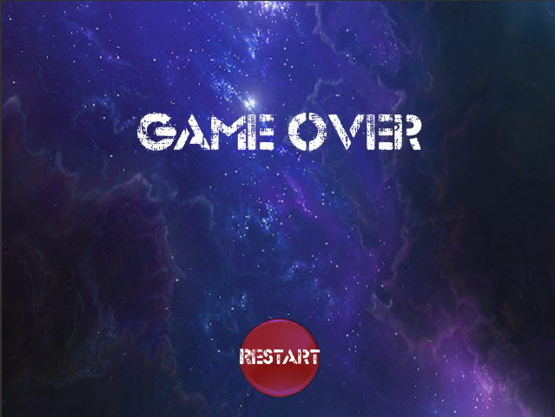

Restart Button

The Game over scene is very similar to the main menu scene, they both have only one option for the player to start the game again.

Characters/Vehicles

The main character’s avatar is a spacecraft. Which can shoot laser’s at incoming asteroids. The asteroids are circular shaped and slow moving. Survival avatar is a man on a broken space rock, once they are saved they will scream YAY!

Enemies

The enemies in the game will be dropping from the top of the screen at random X locations. They in groups of 3. The enemies also drift either left or right, some even upwards but at slower speed. Their speed dropping varies anywhere from 2 to 10 units.

Scoring

Score in this game is calculated by how many survivors the player can save. Each survivor counts as one point. Player starts the game with 5 lives, and they must save as many survivors as they can with 5 lives. This does not change anytime in the game.

Sound Index

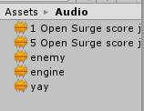

The first audio file is for the main menu, it is a slow and quite sound which is set on a loop. The second audio file is for the endgame scene, it a much louder and faster version of the first file. Enemy audio file is for when player collides with an enemy, and player will lose a life. Engine audio is for the spacecraft engine. YAY! Is the sound for all the survivors once they are saved.

Art / Multimedia Index

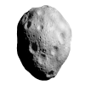Survivors are located on these asteroids.

Survivors

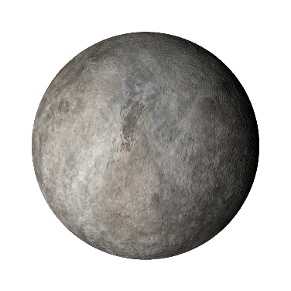Asteroids (enemy)

Explosion once asteroid is shot

Laser firing from space craft

 Void (background), this is on a loop

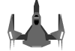Jax’s space craft

Sources

<http://orig11.deviantart.net/c173/f/2009/291/7/9/player_sprite_by_brubee2k.png>

<http://opengameart.org/content/level-finish-fanfares>

[http://opengameart.org/content/rocket-launch-0#](http://opengameart.org/content/rocket-launch-0)

<http://opengameart.org/content/muffled-distant-explosion>

<http://opengameart.org/content/asteroid-generator-and-a-set-of-generated-asteroids>

<http://orig05.deviantart.net/2c61/f/2012/191/9/e/moon_1___stock_by_theedeonknight-d56pr1e.png>

<http://orig10.deviantart.net/bfc5/f/2010/219/1/b/void_logo_by_codenamexen.jpg>

<http://beta.rspms.com/icons/Bright%20Icons/Buttons%202D/Button%20Circle%20Orange.png>

<https://github.com/CentennialCollege/COMP305-MailPilotDemo>